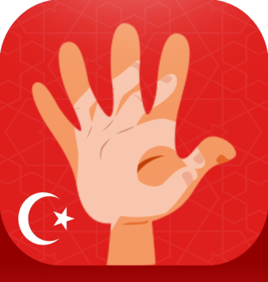

[**The English School Of Kyrenia**](https://play.google.com/store/apps/developer?id=The+English+School+Of+Kyrenia)



**Privacy Policy**

Thank you for using Turkish Sign Language Tutor! The aim of this policy is to facilitate your understanding of how we handle your sensitive data.

**What permission do we ask for?**

There are 3 permissions requested by the app: READ_PHONE_STATE, RECORD_AUDIO, WRITE_EXTERNAL_STORAGE.

**Why are these permissions requested?**

The only reason why these permissions are needed is because the plugin that is used for playing the sounds, Cordova-Plugin-Media requires these permissions for functioning. None of your personal information is stored or collected. We use the sounds in the Alphabet section of the app that is aimed to English-speaking users. This will help them to learn how to pronounce certain Turkish letters.

**Contact Us**

If there are any questions regarding our privacy policy please contact us via our email: [eskplaystore@gmail.com](mailto:eskplaystore@gmail.com)